Graphic Helper Files
Introduction
In this unit we will be creating two new files to help us work with graphics in the future.

Loading Image Review:
We will load images using the below code:
try
{
img1 = ImageIO.read((new File("Image1Location")));
img2 = ImageIO.read((new File("Image2Location ")));
}
catch(Exception e)
{
System.out.println("Error Loading Images: " + e.getMessage());
}
The code attempts to load 2 images. If it fails you will see an error message

Buffered Image Overview:
Attributes:
Name | Description
public static final Attributes:
TYPE_INT_ARGB | RGB color with transparency
TYPE_INT_RGB | RGB with no transparency

Constructor:
Constructor | Description
BufferedImage(int width, int height,  int imageType) | Creates a bufferedImage based on the received specifications.  Width – The width of the image  Height – The height of the image  imageType – the graphics mode of the image  imageTypes:  TYPE_INT_ARGB – RGB color with transparency  TYPE_INT_RGB – RGB with no transparency

Methods:
Return Type | Name | Description
ColorModel | getColorModel() | Returns the color model of the image.  We will use the color model to get the transparency type of the image.  Example:  int transparency = img.getColorModel().getTransparency();  The two values for transparency:  Transparency.BITMASK  Transparency.TRANSLUCENT
int | getWidth() | Returns the width of the image
int | getHeight() | Returns the height of the image
Graphics | getGraphics() | Returns the graphics of the image
int | getRGB(int x, int y) | Returns the int value of the color at (x, y)
void | setRGB(int x, int y, int rgb) | Changes the color at (x, y) to rgb

New Graphics Method:
Methods:
Return Type | Name | Description
void | drawImage(Image img,  int dx1, int dy1,  int dx2, int dy2,  int sx1, int sy1,  int sx2, int sy2,  ImageObserver observer) | Draws an image based on source and destination points.  img – the image to be drawn  The source points define a rectangle of the pixels you want to draw:  (sx1,sy1) – is the top left corner  (sx2,sy2) – is the bottom right corner  The destination points define where point 1 and point 2 will end up:  (dx1,dy1) – is where source point one will end up  (dx2,dy2) – is where source point one will end up

DrawImage Examples:
Source | Destination
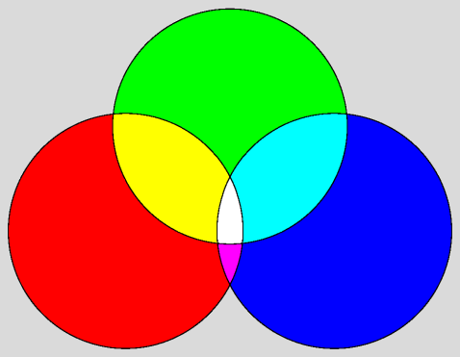  S2  S1 | D2  D1
S2  S1 | D2  D1
S2  S1 | D2  D1

Colors Overview:
Attributes:
Type | Name | Description
int | BLACK | Value for black
int | BLUE | Value for blue
int | CYAN | Value for cyan
int | DARK_GRAY | Value for dark gray
int | GRAY | Value for gray
int | GREEN | Value for green
int | LIGHT_GRAY | Value for light gray
int | MAGENTA | Value for magenta
int | ORAGNE | Value for orange
int | PINK | Value for pink
int | RED | Value for red
int | WHITE | Value for white
int | YELLOW | Value for yellow

Constructors:
Name | Description
Color(int r, int g, int b) | Creates a Color with the given (r,g,b) value  r – (0-255)  g – (0-255)  b – (0-255)  0 color off  255 color fully on
Color(float r, float g, float b, float a) | Creates a Color with the given (r,g,b,a).  a is how transparent the color is.  a – (0-255)  0 fully transparent  1 fully opaque
Color(int rgb) | Creates a color from the given value
Color(int rgba, boolean hasalpha) | Creates a color from the given value.  If hasalpha is true it will pull the transparency value from rgba

Methods:
Return Type | Name | Description
Color | brighter() | Creates a brighter version of the calling Color
Color | darker() | Creates a darker version of the calling color.
int | getAlpha() | Returns the alpha value of the color
int | getBlue() | Returns the blue value of the color
int | getRed() | Returns the red value of the color
int | getGreen() | Returns the green value of the color
int | getTransparency() | Returns the transparency mode.

Rotating Images:
Rotating an image is fairly complicated. We will not be covering how each line of code for rotating works.

The below code will rotate images for you:
// img will be the image being rotated
// angle will be the angle for the rotation

// corrects any angle bigger than 360
angle = angle%360;

// Creates the transform for the rotation
AffineTransform affineTransform = new AffineTransform();
affineTransform.setToTranslation(0,0);
affineTransform.rotate(Math.toRadians(angle), img.getWidth()/2, img.getHeight()/2);

// Stores the transparency of the original image
int transparency = img.getColorModel().getTransparency();

// Creates an image to store the rotated version of the original image
BufferedImage rotated =
new BufferedImage( img.getWidth(), img.getHeight(), transparency);

// gets the graphics of the destination image.
Graphics2D g = (Graphics2D) (rotated.getGraphics());

// draws the original image onto the destination image, with the correct rotation
g.drawImage(img, affineTransform, null);

